A TECHNICAL REPORT ON STUDENTS INDUSTRIAL WORK EXPERIENCE SCHEME (SIWES)

HELD AT
AMJAD INTEGRATED SERVICE,
MUBI, ADAMAWA STATE

FROM: OCTOBER, 2023
TO: JANUARY, 2024

BY
Ahmadu Sani
(ST/CS/ND/22/184)

A SIWES REPORT SUBMITED TO THE DEPARTMENT OF COMPUTER SCIENCE, SCHOOL OF SCIENCE AND TECHNOLOGY FEDERAL POLYTECHNIC, MUBI, ADAMAWA STATE, NIGERIA
IN PARTIAL FUFILMENT OF THE REQUIREMENTS FOR THE AWARD OF NATIONAL DIPLOMA (ND) IN COMPUTER SCIENCE

MARCH, 2024

ATTESTATION
I Ahmadu Sani hereby attest that I did my Industrial Attachment Program at Amjad Integrated Service, Mubi, Adamawa State between October, 2023, to January, 2024, and this report is prepared by me and submitted to the SIWES coordinator as required. I understand that all the information contained in this report are correct and will be penalized if found to be false. I also know that the SIWES coordinator may request for additional evidence as requested for reconciliation.

………………………………………… ………………………………..
Ahmadu Sani DATE
(ST/CS/ND/22/184)

CERTIFICATION
This is to certify that Ahmadu Sani with a registration number ST/CS/ND/22/184 undergoes his industrial training SIWES at Amjad Integrated Service, Mubi, Adamawa State. In partial fulfillment of the requirements for the award of National Diploma (ND) in computer science, Federal Polytechnic, Mubi, as certified by the undersign officer.

Mr. Hyellamada Simon …………………………
DEPARTMENTAL SIWES CO-ORDINATOR DATE

DEDICATION
I dedicate this technical report to my lovely parents who gave me all the support and care throughout my SIWES program.

ACKNOWLEDGMENTS
I thank God Almighty for making me to undergo students industrial work experience scheme (SIWES) successfully.
My gratitude goes to my parent for their prayers, financial and moral support during my attachment.
I also appreciate the kind gesture of my brothers and sisters and those who supports me in prayers and contribution during my industrial attachment.
I whole heartedly thank my Head of department Mallam Kassim Mustapha, SIWES coordinator Mr. Hyellamada Simon and all lectures of Computer Science for their effort to ensure my success as their students.
I am greatly indebted to my co-SIWES students to mention, may God strengthen our relationship together and grant us academic excellence.
I sincerely thank you all for your contribution and support.

TABLE OF CONTENTS
Title Page - - - - - - - - - i
Attestation - - - - - - - - - ii
Certification - - - - - - - - - iii
Dedication - - - - - - - - - iv
Acknowledgements - - - - - - - - v
Table of contents - - - - - - - - vi

CHAPTER ONE: INTRODUCTION
1.1 Brief History of SIWES - - - - - - 1
1.2 Aims and Objectives of SIWES - - - - - 2
1.3 Roles of student - - - - - - - 2
1.4 Objectives of the report - - - - - - 2

CHAPTER TWO: HISTORY OF THE ORGANIZATION
2.1 Organizational chart - - - - - - - 3
2.2 Brief history of the organization - - - - - - 3

CHAPTER THREE: WORK EXPERIENCE I
3.1 Introduction to Networking - - - - - - 4

CHAPTER FOUR: WORK EXPERIENCE II
4.1 Introduction to Visual Basic - - - - - - 9

CHAPTER FIVE: SUMMARY, CONCLUSION AND RECOMMENDATIONS
5.1 Summary - - - - - - - - - 14
5.2 Conclusion - - - - - - - - 14
5.3 Recommendation - - - - - - - - 14
Reference - - - - - - - - - 15

CHAPTER ONE: INTRODUCTION
1.1 BRIEF HISTORY OF SIWES
SIWES was founded in 1973 by ITF (Industrial Training Funds) to address the problem of tertiary institution graduates' lack of appropriate skills for employment in Nigerian industries. The Students' Industrial Work Experience Scheme (SIWES) was founded to be a skill training programme to help expose and prepare students of universities, Polytechnics and colleges of education for the industrial work situation to be met after graduation.
This system facilitates the transfer from the classroom to the workplace and aids in the application of knowledge. The program allows students to become acquainted with and exposed to the experience required in handling and operating equipment and machinery that are typically not available at their schools.
Prior to the establishment of this scheme, there was a rising concern and trend among industrialists that graduates from higher education institutions lacked appropriate practical experience for employment. Students who entered Nigerian universities to study science and technology were not previously trained in the practical aspects of their chosen fields. As a result of their lack of work experience, they had difficulty finding work.
As a result, employers believed that theoretical education in higher education was unresponsive to the needs of labor employers. Thousands of Nigerians faced this difficulty till 1973. The fund's main motivation for establishing and designing the scheme in 1973/74 was launched against this context.
The ITF (Industrial Training Fund) organization decided to aid all interested Nigerian students and created the SIWES program. The federal government officially approved and presented it in 1974. During its early years, the scheme was entirely supported by the ITF, but as the financial commitment became too much for the fund, it withdrew in 1978. The National Universities Commission (NUC) and the National Board for Technical Education (NBTE) were given control of the scheme by the federal government in 1979. The federal government handed over supervision and implementation of the scheme to ITF in November 1984. It was taken over by the Industrial Training Fund (ITF) in July 1985, with the federal government bearing entire responsibility for funding.

1.2 AIMS AND OBJECTIVES OF SIWES
The Industrial Training Fund’s Policy Document No. 1 of 1973 which established SIWES outlined the objectives of the scheme as:
- Provide an avenue for students in Institutions of higher learning to acquire industrial skills and experience in their respective courses of study.
- Prepare students for the Industrial Work situation they are likely to experience after graduation.
- Expose students to work methods and techniques of handling equipment and machinery that may not be available in their Institutions.
- Make the transition from school to the world of work easier; and enhance students’ networks for later job placements.
- Provide students with an opportunity to apply their knowledge to real work situations, thereby bridging the gap between theory and practice; and vi. Enlist and strengthen Employers’ involvement in the entire educational process; thereby preparing the students for employment in Industry and Commerce.

1.3 ROLES OF STUDENT
- Attend SIWES orientation programme before going on attachment.
- Comply with the establishment’s rule and regulation.
- Arrange living accommodation during the period of attachment.
- Record all training activity done and other assignment in the log book.
- Complete SPEI from ITF, FORM 8 and get it endorsed by the employer for submission to the ITF.

1.4 OBJECTIVES OF THE REPORT
The objectives of the SIWES report are;
- To make thorough explanation of the work done during my four-month industrial training.
- To fulfill the requirement for national diploma in computer science.
- To contribute to the body of knowledge and to enhance the understanding of the writer about a similar or same job.

CHAPTER TWO: HISTORY OF THE ORGANIZATION

2.1 ORGANIZATIONAL STRUCTURE
Director

Admission officer
Exam officer
Application Lecturer
Networking Lecturer
Programming Lecturer
Maintenance Lecturer

Security
Cleaner

Figure 2.1: Organizational Chart

2.2 BRIEF HISTORY OF AMJAD INTEGRATED SERVICES
AMJAD is a leading web development company. It provides all kinds of mobile application development, web application development, cloud server administration services to its clients. Our main focus is to build awesome products for our clients to maintain their business more secured, fast, maintainable and reliable.
HISTORY
AMJAD INTEGRATED SERVICES NIG LTD is registered with Federal Republic of Nigeria under Corporate Affairs Commission by the government. Our registration number is BN248590. This company has 50 desktop Computers and 3 laptops with 7 numbers of staff, this company is located at Lokuwa near Emir’s Palace GSS junction.

CHAPTER THREE: WORK EXPERIENCE I
3.1 INTRODUCTION TO NETWORKING
Networking, also known as computer networking, is the practice of transporting and exchanging data between nodes over a shared medium in an information system. Networking comprises not only the design, construction and use of a network, but also the management, maintenance and operation of the network infrastructure, software and policies.
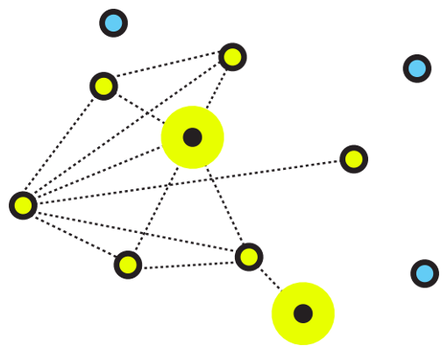
Figure 3.1: An illustrative image for networking

3.1.1 Types of Networking
There are two primary types of computer networking: wired networking and wireless networking.
Wired networking requires the use of a physical medium for transport between nodes. Copper-based Ethernet cabling, popular due to its low cost and durability, is commonly used for digital communications in businesses and homes. Alternatively, optical fiber is used to transport data over greater distances and at faster speeds, but it has several tradeoffs, including higher costs and more fragile components.
3.1.2 Components of Networking
Computer networking requires the use of physical network infrastructure -- including switches, routers and wireless access points -- and the underlying firmware that operates such equipment. Other components include the software necessary to monitor, manage and secure the network.
3.1.3 Networking wiring colour code and crimping.
Purchasing Ethernet cables can be quite expensive and pre-made lengths are not always the length you need. Making Ethernet cables is easy with a box of bulk Category 5e Ethernet cable and RJ-45 connectors that are attached to the cut ends of your preferred cable length.
Bulk Ethernet Cable - Category 5e or CAT5e
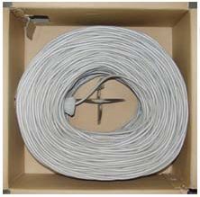
Figure 3.2: Bulk Ethernet Cable - Category 5e or CAT5e
(You may also use Category 6 or CAT6 cabling which has higher performance specifications and is about 20% more expensive than CAT5e.)
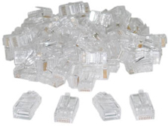
Figure 3.3: Bulk RJ45 Crimpable Connectors for CAT-5e
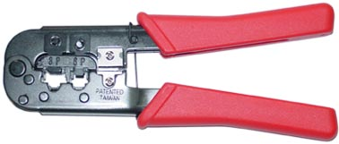

Figure 3.7: RJ-45 Crimping tool
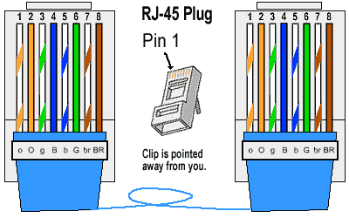

Figure 3.4: RJ45 diagram

3.1.4 Types of ethernet cables
There are two kinds of Ethernet cables you can make, Straight Through and Crossover.
Straight through Ethernet cables are the standard cable used for almost all purposes, and are often called "patch cables". It is highly recommend you duplicate the color order as shown on the left. Note how the green pair is not side-by-side as are all the other pairs. This configuration allows for longer wire runs.
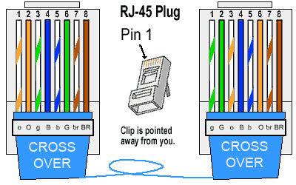

Figure 3.5: Straight through cable
Crossover Cables - The purpose of a Crossover Ethernet cable is to directly connect one computer to another computer (or device) without going through a router, switch or hub.
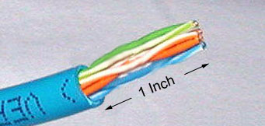
Figure 3.6: Cross over cable
Cut into the plastic sheath about 1 inch (2.5 cm) from the end of the cut cable. The crimping tool has a razor blade that will do the trick with practice.
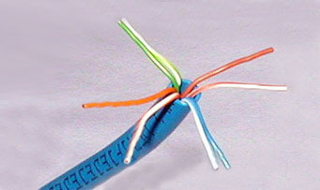
Figure 3.7: Unwind and pair the similar colors.
Pinch the wires between your fingers and straighten them out as shown. The color order is important to get correct.

Figure 3.8: Colour order of cables
Use scissors to make a straight cut across the 8 wires to shorten them to 1/2 Inch (1.3 cm) from the cut sleeve to the end of the wires.

Figure 3.9: Scissors
Carefully push all 8 unstripped colored wires into the connector. Note the position of the blue plastic sleeve. Also note how the wires go all the way to the end.
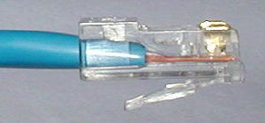
Figure 3.10: Inserting the wires
A view from the top. All the wires are all the way in. There are no short wires.
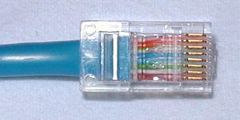
Figure 3.11: Top view of the inserted wires
Wrong Way - Note how the blue plastic sleeve is not inside the connector where it can be locked into place. The wires are too long. The wires should extend only 1/2 inch from the blue cut sleeve. Note how the wires do not go all the way to the end of the connector.

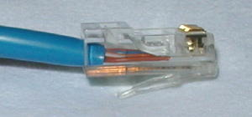
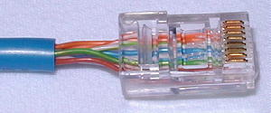

Figure 3.12: Wrong way of inserting the wires

Crimping the Cable ... carefully place the connector into the Ethernet Crimper and cinch down on the handles tightly. The copper splicing tabs on the connector will pierce into each of the eight wires. There is also a locking tab that holds the blue plastic sleeve in place for a tight compression fit. When you remove the cable from the crimper, that end is ready to use.
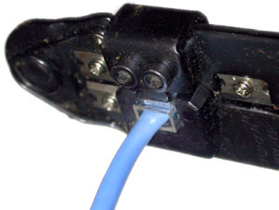
Figure 3.13: Crimping the cable

For a standard "Straight Through" cable, repeat all steps and wire color order on the other end of cable. For a cross-over cable, the other end will have a different color order as shown by the crossover picture above. Make sure to test the cables before installing them. An inexpensive Ethernet cable tester does this quite well.

CHAPTER FOUR: WORK EXPERIENCE II

4.1 INTRODUCTION TO VISUAL BASIC
The Visual Basic 2012 was the programming language that I learnt. It was taught as a platform for developing software programs. Below are some few terms that I learnt.
Program: A program presented to a computer is set of instructions that solve a particular problem.
Programming Language:
Programming Languages refers to the various platforms for writing programs. Each platform has its syntax or rules of operations. Examples of programming Languages include Java, Visual Basic, FORTRAN, Python etc.
Visual Basic is one of the platforms or languages from Visual Studio which contains better tools and language procedure for developing powerful software applications. It is an Object-Oriented Programming Language.

Visual Studio IDE
Microsoft has provided an IDE (Integrated Development Environment) tool called Visual Studio to build applications using programming languages such as C#, F#, Visual Basic, etc., based on our requirements. The Visual Studio IDE will provide a common user interface with various development tools to build applications with different programming languages such as C#, F#, Visual Basic, etc.

HOW TO Create a Project in Visual Studio
After completing a visual studio installation, open visual studio and it will be prompted to sign in for the first time. The sign-in step is optional, so you can skip it, and in the next step, the dialog box will appear and ask you to choose your Development Settings and color theme. Once you select the required options, click on the Start Visual Studio option as shown below.
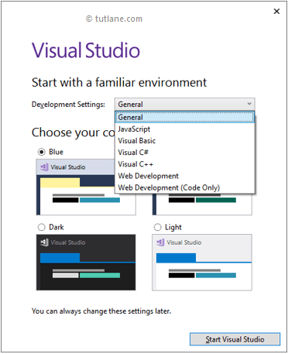
Figure 3.17: Visual Studio IDE start up screen
After the visual studio launch, create a new console application using a visual basic programming language; for that, Go to File à New à select a Project like as shown below.
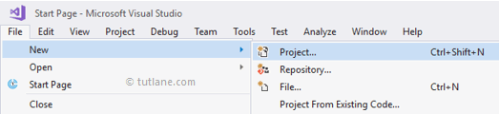
Once you click on Project, a new popup will open in that select Visual Basic from the left pane and choose Console App. In the Name section, give any name for your project and select an appropriate Location path to save your project files, and click OK like as shown below.
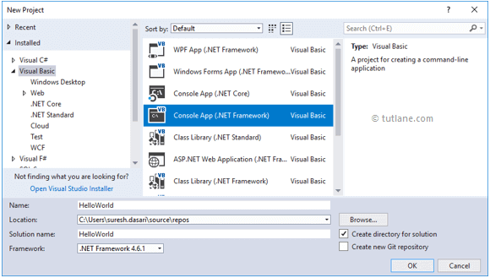
Figure 3.18: Visual Studio New project
Once we click on the OK button, a new console application will be created like as shown below.
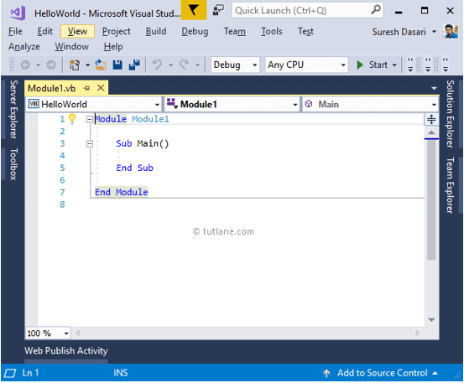
Figure 3.19: Creating new program interface
This is how we can create a console application in a visual basic programming language using a visual studio based on our requirements.
Forms: is the background of your interface of the software you are developing.
Solution Explorer: is where you explore your project Solution
Property Window: is where you change the object properties. Eg, Name, fonts, etc.
Server Explorer: can be used to explorer your database while still working on your VB environment.
VISUAL BASIC TOOLS
There is a difference between a Tool and an Object. A Tool is used to draw an object.
There tools for drawing, and there tools for Language (Language Tools) Instructions
Button: Is used for drawing Buttons which helps in initiating instructions on a program. To do so, a user must click on the button.
TextBox: It is used for adding a TextBox Object which may serve as both an input or output box. It can be used as a page Layout for word processing application.
Label: it is used to draw a Label Object which is used to describe other object. It can also be used as a platform to display some output.
ComboBox: it is used to draw a ComboBox Object which has a pull down list that displays list items. You can add the list in the items property or add them through codes.
RadioButton: the Radio Button Tool is used to draw list of option buttons. It is commonly used in multiple-choice programs such as CBT systems or quizzes.
MenuStrip: the MenuStrip tool is used to add a menu bar to an existing form. The menu bar items can further be added and edited automatically.
ProgressBar: the progressbar is used to indicate the process of an actionespecially when there is a time frame given to it.
VISUAL BASIC VARIABLES
In Visual Basic, Variables will represent storage locations, and each variable will have a particular data type to determine the type of values the variable can hold. Visual Basic is a Strongly Typed programming language. Before we perform any operation on variables, it’s mandatory to define the variable with a required data type to indicate the type of data the variable can hold in our application.

Syntax of Visual Basic Variables Declaration
Dim [Variable Name] As [Data Type]
Dim [Variable Name] As [Data Type] = [Value]
If you observe the above variable declarations, we added a required data type after the variable name to tell the compiler about the type of data the variable can hold.
Item | Description
Dim | It is useful to declare and allocate the storage space for one or more variables.
[Variable Name] | It’s the variable's name to hold the values in our application.
As | The As clause in the declaration statement allows you to define the data type.
[Data Type] | t’s a type of data the variable can hold, such as integer, string, decimal, etc.
[Value] | Assigning a required value to the variable.

Program to Print Hello World
Public Class Form1
Private Sub btnPrint_Click(sender As Object, e As EventArgs) Handles btnPrint.Click
txtOutput.Text = "Hello World"
End Sub
End Class

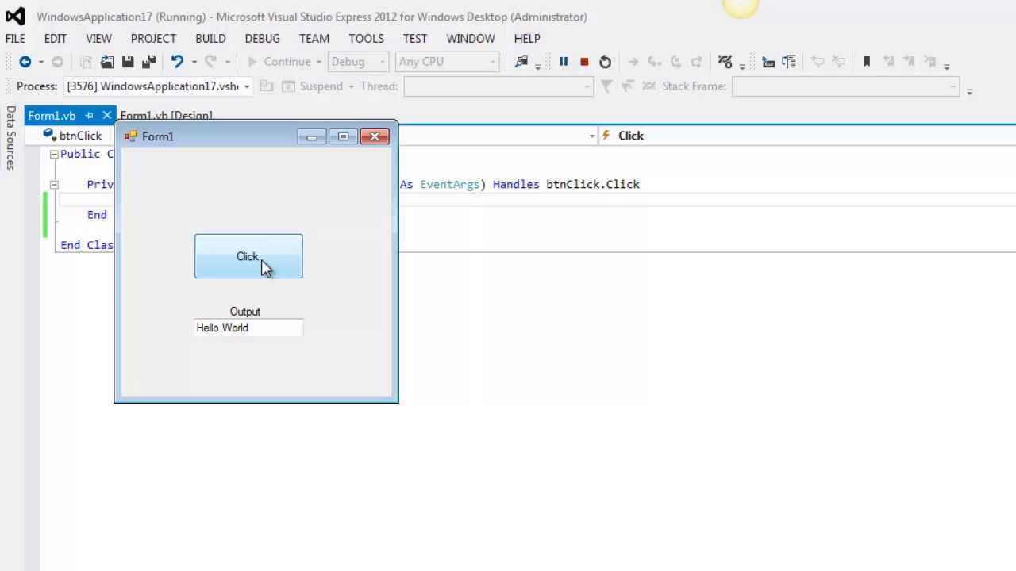

Program to Add two Numbers
Public Class Form1
Private Sub btnAdd_Click(sender As Object, e As EventArgs) Handles btnAdd.Click
' Declare variables to store the numbers
Dim num1, num2, result As Double

' Check if the input fields are not empty
If Not String.IsNullOrEmpty(txtNum1.Text) AndAlso Not String.IsNullOrEmpty(txtNum2.Text) Then
' Parse the values from the text fields to Double data type
If Double.TryParse(txtNum1.Text, num1) AndAlso Double.TryParse(txtNum2.Text, num2) Then
' Add the numbers
result = num1 + num2
' Display the result in the third text field
txtResult.Text = result.ToString()
Else
' Display error message if input is not a valid number
MessageBox.Show("Please enter valid numeric values.")
End If
Else
' Display error message if any input field is empty
MessageBox.Show("Please enter values in both fields.")
End If
End Sub
End Class

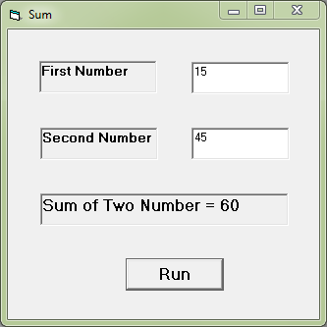
CHAPTER FIVE: SUMMARY, CONCLUSION AND RECOMMENDATION

5.1 SUMMARY
The relevance of the SIWES program cannot be over emphasized considering the fact that it has significantly reduced the gap between my theoretical and practical knowledge about computer hardware and software, installations, maintenance and networking. The processes of communication which include data and telecommunication the use of switch in the networking and what networking is all about.
The program is indeed a commendable one in that it affords students ample opportunities of being exposed to good working relationship with colleagues and the field experience with customers. This little exposure has widened my knowledge about my course of study, not only that it has automatically changed my views about lift in general. The firm at large has taught me how to be independent of my own how to be conscious of my health and safety at its peak relating to the environment where I carried out my SIWES program. It was indeed a highly rewarding experience to be with Amjad Integrated Service, Mubi, Adamawa State.
5.2 CONCLUSION
In conclusion, I thank ITF in general for their effort towards the Student Industrial Training Scheme. The contribution that the industrial training offered to student will not be over emphasized. It has exposed me seriously to a certain depth and length of practical capability on Web Designs.
It has also acquainted me with the working condition, which I am expected to encounter in the near future.
Finally, I have a strong believe that this comprehensive based on the experience, I acquired during the industrial training scheme will convince every user training is not difficult.
I therefore strong conclude that the continuous existence of SIWES programme as it is very necessary since it plays a dominant role in the development of student of Computer Science in the acquisition of practical experience.
5.3 RECOMMENDATIONS
Below are the recommendations that should be given serious consideration so as alleviate the suffering of students undergoing SIWES.
Firstly, the Federal Government of Nigerian should make a positive effort in reducing the overall cost of production so that companies should be producing to fill capacity and accommodate SIWES populaces. Also, certain monthly allowance may be given to the student by company accepted then (student to ease transportation problem).
Secondly, the Industrial Training Fund (ITF), should try and increase the money paid at the end of SIWES to the student so as to justify the Cost of Living we experienced.
Finally, the ITF official should please continue visiting the students, to ensure that what they are learning is in line with the ITF requirement.
REFERENCES
Edward, B. (2003). The Effect of SIWES on a student, Federal Ministry of Works, Lagos. Nigeria.
John, Doe (2008). Introduction to web development: responsive designs, McGraw Print New York.
Samuel, J. (2017). Visual Basic (VB) Tutorial Overview. Retrieved 25 July, 2022 from www.tutlane.com/tutorial/visual-basic

